**Format**

A data frame containing 5,190 observations on 12 variables.

visits

Number of [doctor](https://rdrr.io/cran/AER/man/DoctorVisits.html) visits in past 2 weeks.

gender

Factor indicating gender.

age

Age in years divided by 100.

income

Annual income in tens of thousands of dollars.

illness

Number of illnesses in past 2 weeks.

reduced

Number of days of reduced activity in past 2 weeks due to illness or injury.

health

General health questionnaire score using Goldberg's method.

private

Factor. Does the individual have private health insurance?

freepoor

Factor. Does the individual have free government health insurance due to low income?

freerepat

Factor. Does the individual have free government health insurance due to old age, disability or veteran status?

nchronic

Factor. Is there a chronic condition not limiting activity?

lchronic

Factor. Is there a chronic condition limiting activity?

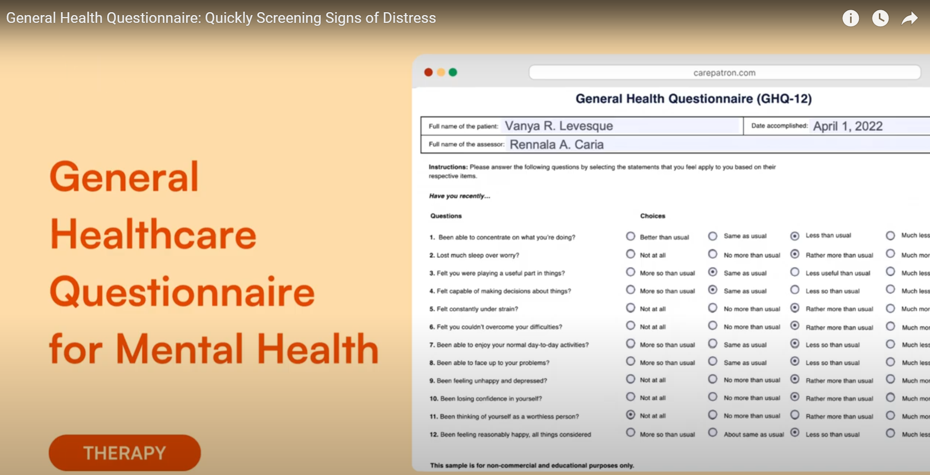

|  |  |  |
| --- | --- | --- |
| **GHQ-12 Items** |  |  |
| 1. Able to concentrate | 0.57 | - |
| 2. Lost much sleep | - | 0.69 |
| 3. Playing useful part | 0.81 | - |
| 4. Capable of making decisions | 0.56 | - |
| 5. Under stress | - | 0.68 |
| 6. Could not overcome difficulties | - | 0.62 |
| 7. Enjoy normal activities | 0.57 | 0.46 |
| 8. Face up to problems | 0.64 | - |
| 9. Feeling unhappy and depressed | - | 0.64 |
| 10. Losing confidence | 0.62 | - |
| 11. Thinking of self as worthless | 0.79 | - |
| 12. Feeling reasonably happy | - | 0.56 |